**CACERES JELLA MARIE B.**

**BSIT 3-C**

**Laravel Application Documentation**

**Overview**

This document outlines the structure and functionalities of a Laravel application that implements user access control, logging, and session management using **MIDDLEWARE**. The application is designed to enforce age restrictions for certain content while providing a user-friendly experience.

## 1. Application Structure

The application is organized into key components, including middleware for handling requests, Blade templates for the user interface, and session management for maintaining user state.

### **1.1 Directory Structure**

* **app/Http/Middleware/**: Contains middleware classes that handle request processing.
* **resources/views/**: Contains Blade templates for the application's views.
* **routes/**: Defines web routes that utilize middleware for access control.

## 2. Middleware Integration

Middleware in Laravel acts as a bridge between the request and response, allowing for filtering and modifying requests.

### **2.1 Kernel Configuration**

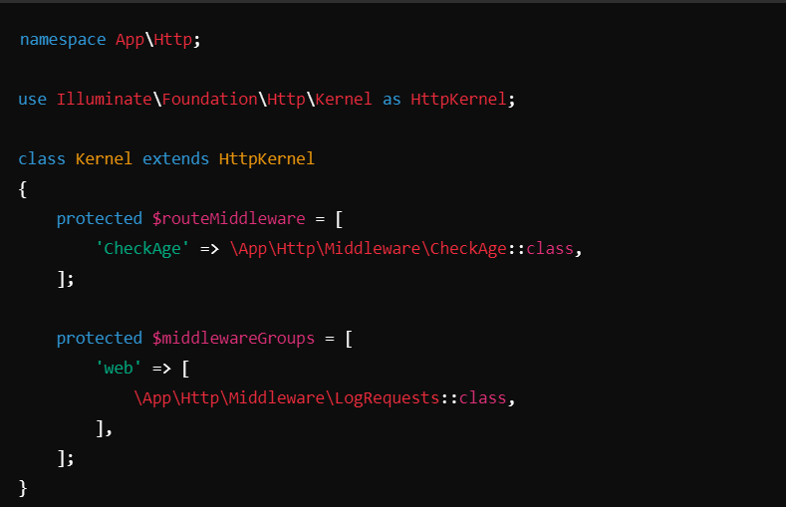The Kernel class is responsible for registering middleware globally and defining middleware groups.

**2.2 Route Middleware**

* **CheckAge Middleware**: This middleware checks the user's age based on session data and manages access to certain routes. If the age is not set, users are redirected to a welcome page.

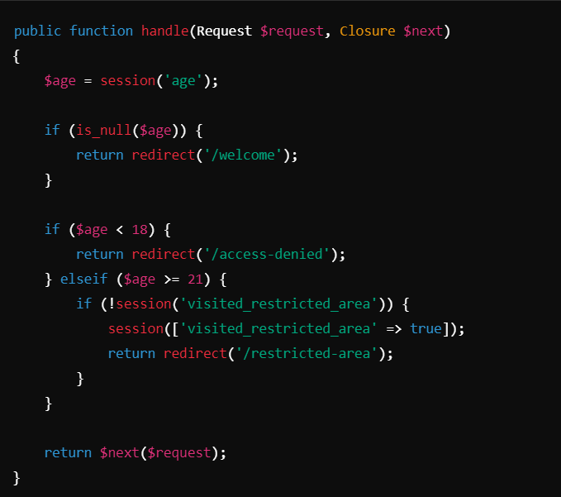  
  
  
  
  
  
  
  
  
  
  
**3. User Access Control**

The CheckAge middleware plays a vital role in managing access based on the user’s age.

### **3.1 Redirect Logic**

* Redirects users under 18 to an access denied page.
* Prompts users without age information to enter their age on the welcome page.
* Allows access for users aged 18-20 and restricts access for those over 21 if they haven’t previously visited the restricted area.

**4. Logging Functionality**

### **4.1 LogRequests Middleware**

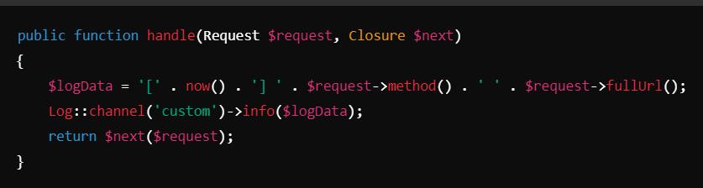This middleware logs incoming requests, capturing the HTTP method and URL, which is essential for monitoring and debugging.

## 5. Session Management

The application utilizes Laravel's session management to store the user's age, enabling stateful interactions across requests.

### **5.1 Session Handling**

* Age is stored in the session, allowing the application to maintain user context and manage redirects accordingly.

## 6. User Interface Components

### **6.1 Blade Templates**

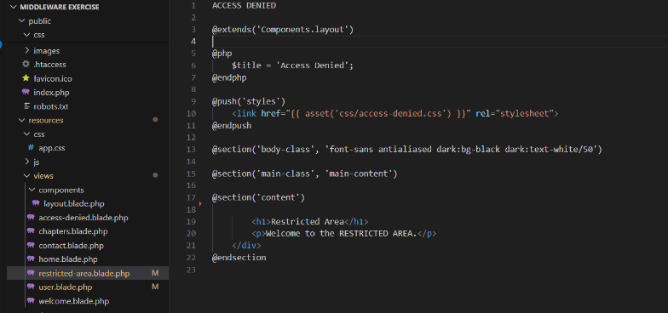The application uses Blade templates to define the layout and structure of web pages.

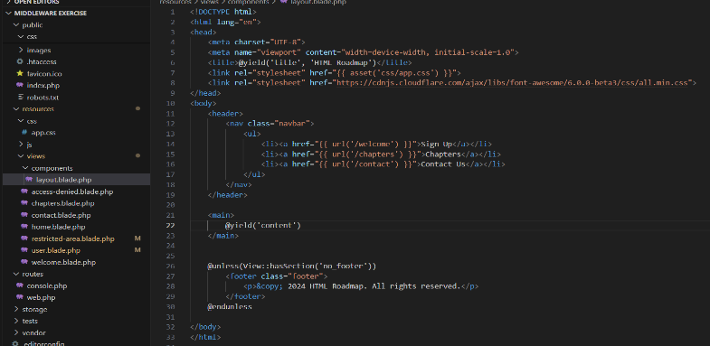

* **restricted-area.blade.php**: Displays an access denied message when users under 18 attempt to access restricted content.
* **layout.blade.php**: Provides a standard layout for navigation and footer elements across the application.

### **6.2 CSS Styling**

CSS styles ensure that the application is visually appealing and responsive, with hover effects and appropriate color schemes for readability.

## 7. Customization and Scalability

The structure allows for easy customization and scalability:

* Additional middleware can be registered in the Kernel.
* New routes can leverage existing middleware for access control.
* UI elements can be modified in Blade templates and CSS without affecting backend logic.

## 8. Future Enhancements

### **8.1 Enhanced Logging**

Implement detailed logging features that track response times and user actions.

### **8.2 Role-based Access Control**

Expand the age-checking mechanism to include user roles for more granular access control.

### **8.3 User Notifications**

Add functionality to notify users when they attempt to access restricted content or when their session is about to expire.

**Web Pages:  
  
1. home.blade.php  
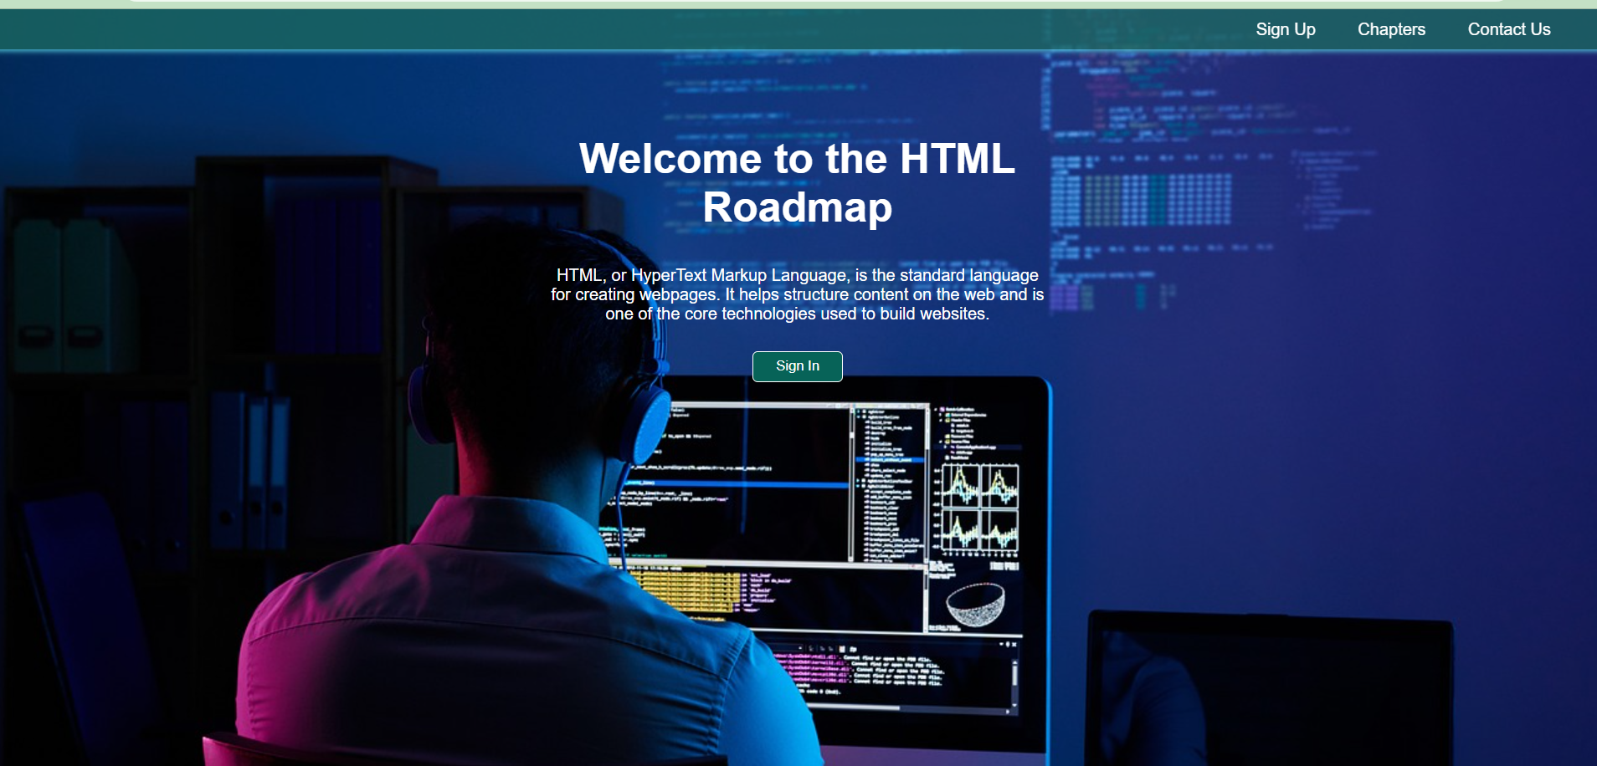**

**2. Welcome.blade.php**

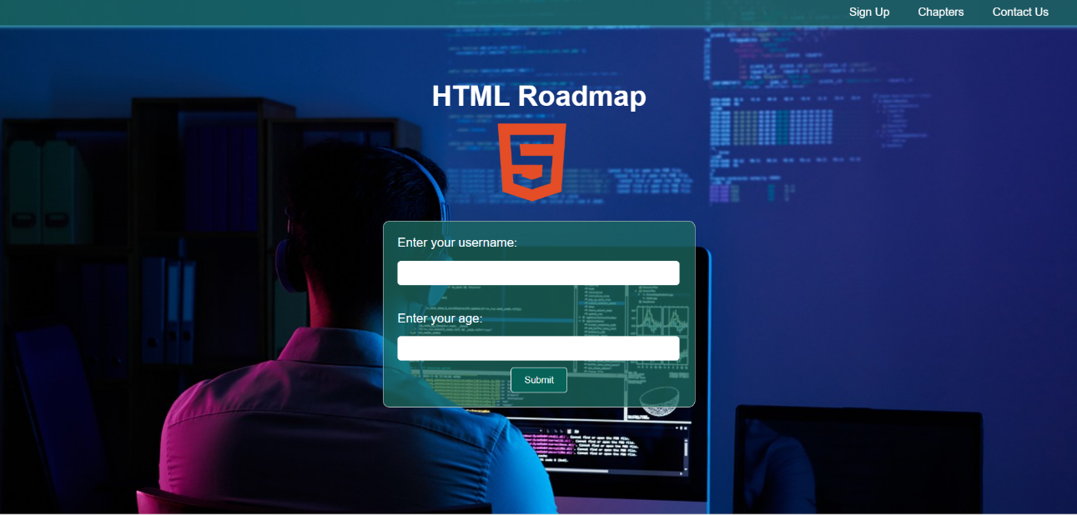

**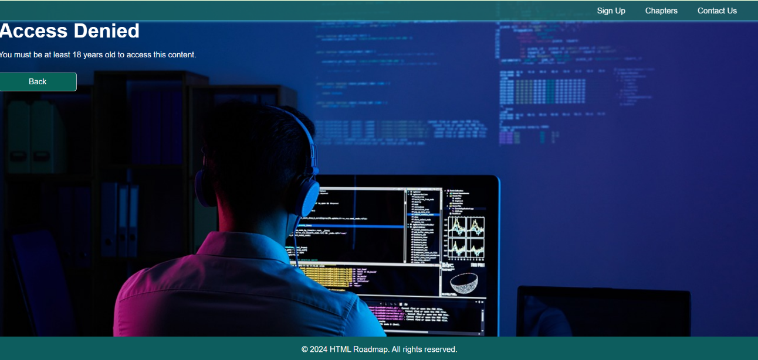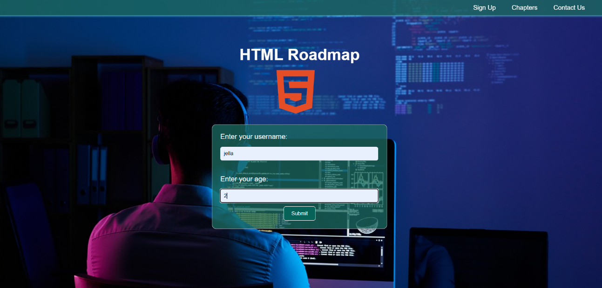  
3.**

**4.**

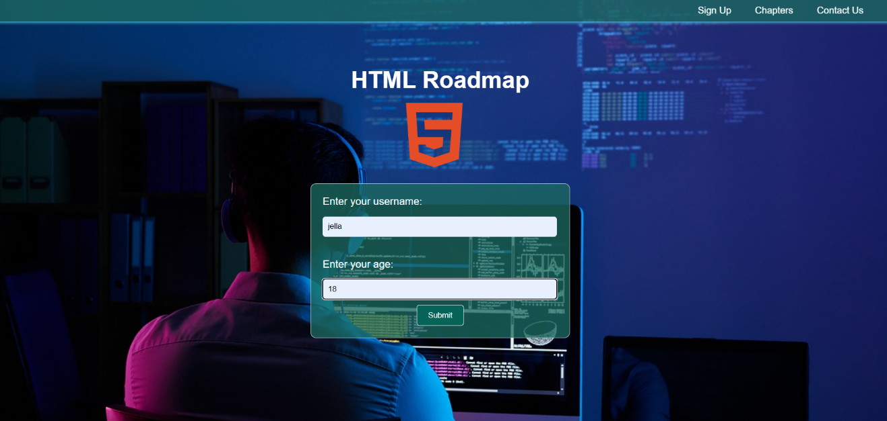**5. If the user meets the required input,**

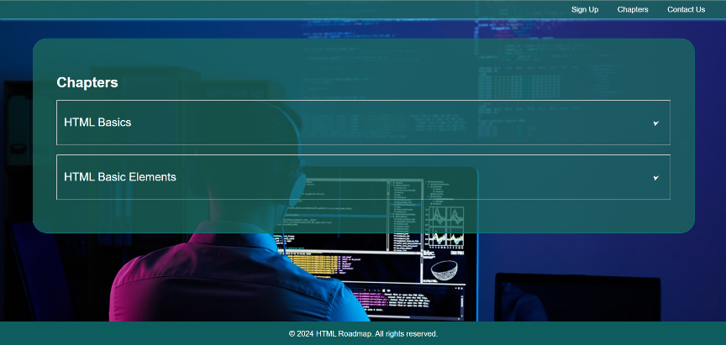**6. She/He will be automatically accesed/ directed to the Chapter.blade.php**

**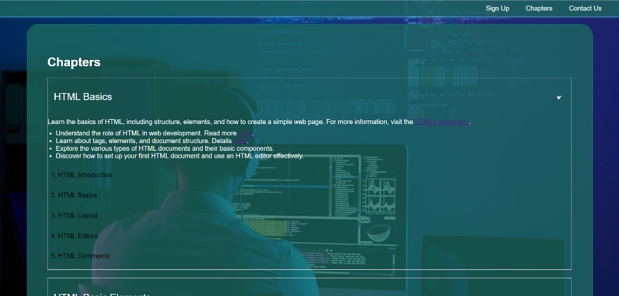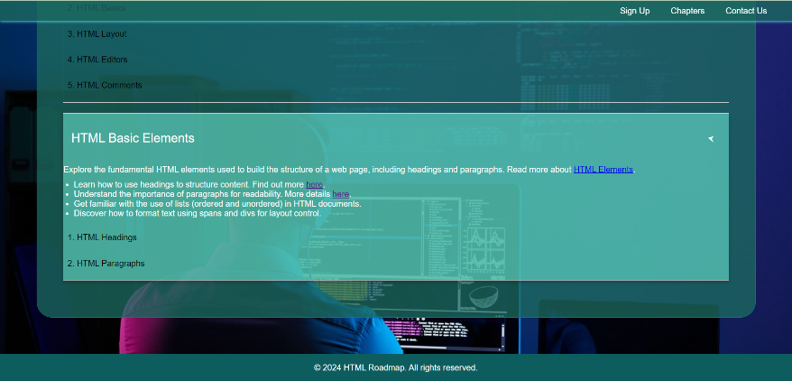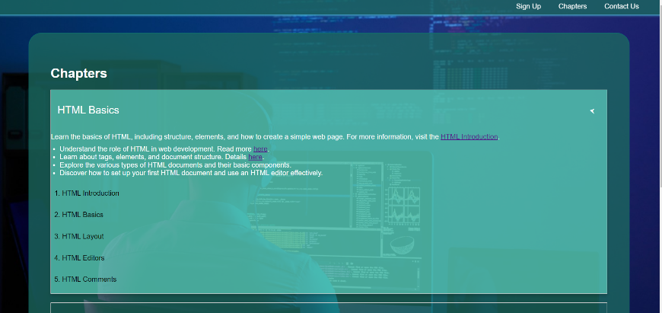  
  
  
  
  
  
  
  
  
  
  
  
  
  
  
  
  
  
  
  
Additional info: If the user doesn’t meet the requirement, he/she cannot be able to accessed any of these pages.**

**7. Contact.blade.php**

